Load IAR

An IAR is an Inventory Archive - all inventory, or an object, image, mesh, or a folder. You click the Menu to load a Free IAR from the Outworldz, and a list of free IARs appears:

The name, file size, and the credits/license for the IAR appears when you hover your mouse over the photo.

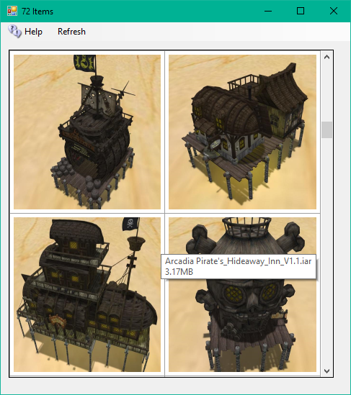

Clicking any photo brings up a folder chooser box. The default is "/Objects", but you can load your IAR to the root of your Inventory with "/", or to a specific folder, such as /Textures.

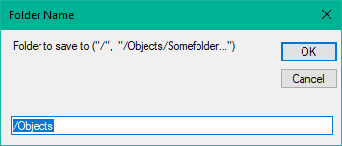

After clicking Okay it will show an avatar First and Last Name box

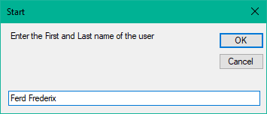

After clicking Okay it will show a password box. Enter the password for that Avatar.

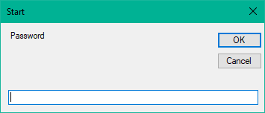

The inventory will load in one of the Dos boxes.

You may need to re-login in order to see your new inventory item.

Links:

http://opensimulator.org/wiki/Inventory_Archives

